HandIn 1) Table of runs: WITHOUT server congestion
λ  1.0 fixed | μ  0.25 fixed | hps degree | Theoretical ρ (%) = ? ∗ | gpss result ρ (%) | avg(Wcj) | L = avg(n(t)) | MAX  L in S | RN1 seed | RN2 seed
 |  | 8 | - | 0.991 | 3.996 | 98.864 | 8 | 464541 | 785545
 |  | 16 | - | 0.493 | 4.023 | 4.129 | 16 | 169420 | 420169
 |  | 32 | - | 0.250 | 3.997 | 3.997 | 32 | 235487 | 383274
 |  | 64 | - | 0.126 | 4.058 | 4.058 | 64 | 534232 | 782575

Table of runs: WITH server congestion

λ  1.0 fixed | μ  0.25 fixed | hps degree | Theoretical ρ (%) = ? ∗ | gpss result ρ (%) | avg(Wcj) | L = avg(n(t)) | MAX  L in S | RN1 seed | RN2 seed
 |  | 8 | - | 0.991 | 6.029 | 99.952 | 8 | 464541 | 785545
 |  | 16 | - | 0.493 | 6.093 | 6.087 | 16 | 169420 | 420169
 |  | 32 | - | 0.250 | 5.171 | 5.242 | 32 | 235487 | 383274
 |  | 64 | - | 0.126 | 4.653 | 4.667 | 64 | 534232 | 782575
 |  | 128 | - | 0.062 | 4.263 | 4.274 | 128 | 523412 | 798483

HandIn 2)
a) Non-congestion case for hps degree 16, histogram of L values.
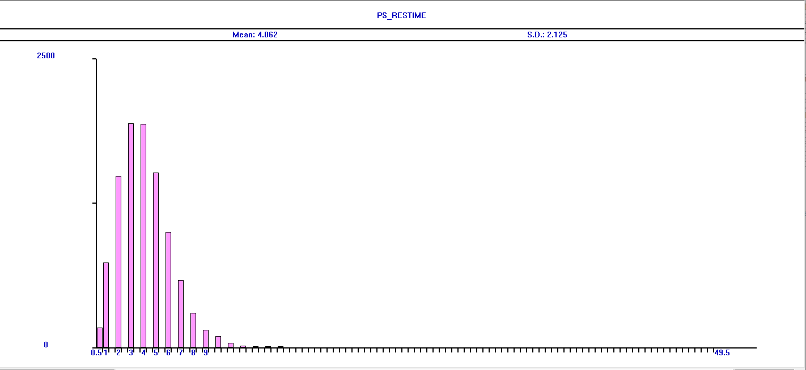

b) Non-congestion case for hps degree 16, histogram of the number of servers requested by cj.
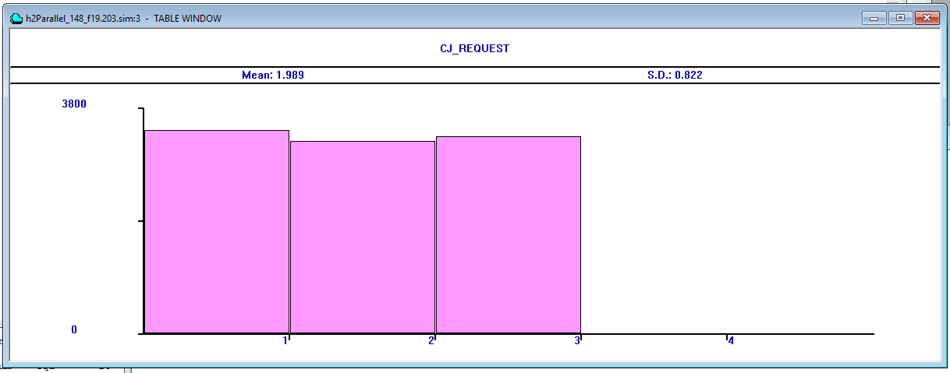

c) Congestion case for hps degree 16, histogram of L values
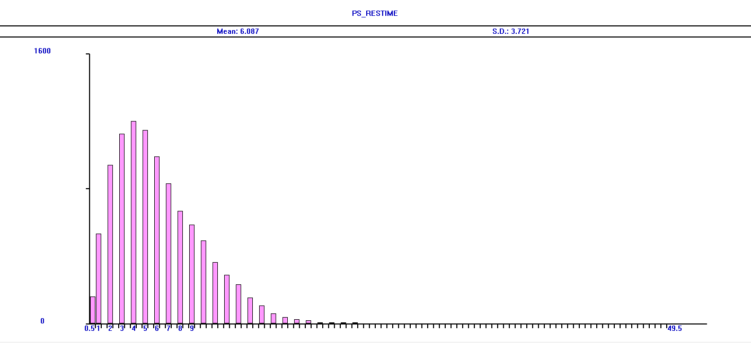

HandIn 3)
a) Congestion case for hps degree 16, Source code.

; +++++++++++++++++++++++++++++++++++++++++++++++++++++++++++++++++++++++++++++++++++++++++++++++
; Parallel server example , 10-1-2019
; Model time unit (t.u.): 1 clock tick = 1 minute; cj represents customer#j
; Usage: Start a simulation via Command: start n, where n = number of cj to serve, 10000 in this case.
; Simulation termination condition: tc becomes 0
; +++++++++++++++++++++++++++++++++++++++++++++++++++++++++++++++++++++++++++++++++++++++++++
clear ; Remove any residual info from previous gpssW runs

; EQU statements to make our life a tad easier
ps_ia_mean equ 1 ; ps {ia} times mean
ps_service_mean equ 4 ; Mean of ps service durations
ps_cong equ 0.45 ; value used to add congestion!
cj_req equ 1 ; customer number of server request
current_L equ 1 ; L is average count of cj

; SAVEVALUE example use
INITIAL x$ps_svrDuration,0 ; initialize variable to temp. save each cj's service duration

seed1 equ 169420 ; set seedVal to some 6-digit value
seed2 equ 420169 ; set SeedVal to another 6-digit value
rmult seed1,seed2 ; seed the SeedVals for the rn generators

; setup our table(s)
; gpssW SNA (an internal function) named M1 returns, when referenced in a tr, that tr is accumulated model restime
ps_restime table M1,0.5,0.5,20 ; cj residence duration dist.
ps_srvtime table x$ps_svrDuration,0.5,0.5,20 ; cj service duration dist.
ps_svrutil table q$ps_cj_in_service,1,1,100 ; serverUtil Stats
cj_request table p$cj_req,1,1,5 ; cj server number request histogram.

; Generate our servers
ps storage 16 ; set server degree to this
srvNum equ 16 ; same here, why not

init_ps generate 0,,0,1,1 ; create n parallel service servers, only once
enter ps,srvNum ; Initialize all ps servers for use by cj
terminate

cj generate (exponential(1,0,ps_ia_mean)),,,10000 ; exponential {ia} dist., limit is 10,000 cj arrivals
queue ps_res_time ; Start cj residence duration stats

assign cj_req,(RN2@3+1) ; customer gets an arbitrary number of servers (<= 3)
tabulate cj_request ; Tabulate the request number for interest
test GE s$ps,p$cj_req ; Give customer requested amount of servers.. if applicable at that moment
queue ps_srv ; Start cj service duration stats

leave ps,p$cj_req ; Allocate server(s) per cj
queue ps_cj_in_service ; Start number of cj in service stats

tabulate ps_svrutil ; Store this value in svr_util for what is hopefully our L
savevalue ps_svrDuration,(Exponential(1,0,ps_service_mean)) ; Temp save this cj's service duration
advance x$ps_svrDuration ; Do the service Duration

depart ps_cj_in_service ; end number of cj in service stats
enter ps,p$cj_req ; Service Finished, return cj's server(s) to hps
advance ((ps_cong)#((r$ps)^2)/(r$ps)) ; add congestion to the mix!

depart ps_srv ; End cj service duration stats
depart ps_res_time ; End cj residence duration stats
tabulate ps_srvtime ; increment service duration histogram for each cj
tabulate ps_restime ; increment residence duration histogram for each cj
terminate 1

b) Congestion case for hps degree 16, Report containing Queue and Storage sections.
